craigslist > manage posting | log in to your account  (Apply for Account)

Your posting can be seen at http://losangeles.craigslist.org/sfv/com/3072477022.html.
You can make changes to the content of your post.
This will remove your posting from active listing.

los angeles craigslist > SF valley > community > general community

AOL Web Search Of Nicole Kidman Declares God Is Randall Craig Johnson

Date: 2012-06-11, 11:25PM PDT
Reply to: randallcraigjohn@live.com

http://www.randalljohnsonmurals.com/RandyGod/index.php?pr=RandallEmbraced6
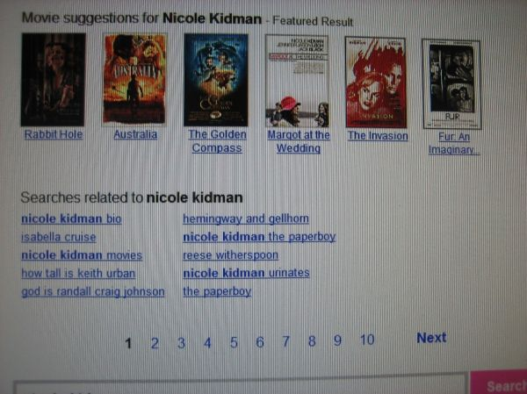
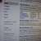

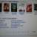

- it's NOT ok to contact this poster with services or other commercial interests
PostingID: 3072477022

FORMAT:
slimregularauto
- POST/EDIT/DELETE : " AOL Web Search Of Nicole Kidman Declares God Is Randall Craig Johnson" ( general community)‏
1:25 AM
Reply ▼

craigslist - automated message, do not reply

Add to contacts
To randallcraigjohn@live.com
IMPORTANT - FURTHER ACTION IS REQUIRED TO COMPLETE YOUR REQUEST !!!
FOLLOW THE WEB ADDRESS BELOW TO:
- PUBLISH YOUR AD
- EDIT (OR CONFIRM AN EDIT TO) YOUR AD
- VERIFY YOUR EMAIL ADDRESS
- DELETE YOUR AD
If not clickable, please copy and paste the address to your browser:
https://post.craigslist.org/u/YqrfdVa04RGAvesV8OSI_g/zsmdg
PLEASE KEEP THIS EMAIL - you may need it to manage your posting!
Your posting will expire off the site 7 days after it was created.
Thanks for using craigslist!

x-store-info:J++/JTCzmObr++wNraA4Pa4f5Xd6uenss1zcyrLyprXaeMvIfLeh1UcrW83cajtw5/xrO9flsT+CJ8HT8VxEDS6cPokILfXyxR9b4eO2YcVte1f2Dp/Flfevr6AEOf4K6pRy0y14qYX6BZBsJ3oj8w==
Authentication-Results: hotmail.com; sender-id=pass (sender IP is 208.82.238.109) header.from=robot@craigslist.org; dkim=none header.d=craigslist.org; x-hmca=pass
X-SID-PRA: robot@craigslist.org
X-SID-Result: Pass
X-DKIM-Result: None
X-Message-Status: n:0:n
X-AUTH-Result: PASS
X-Message-Delivery: Vj0xLjE7dXM9MDtsPTE7YT0xO0Q9MTtHRD0xO1NDTD0w
X-Message-Info: NhFq/7gR1vTvTqmPqDcS3Y0sEvINzEnfxuZvKgsTIZOPQHonFYFVQQYBdgtEdnCxFzNfG2Rhxi57Fp+gjumogsy2ftbeEts7zPm/XatyWFAtQu1Ccfzo+Iic/bdAJvYRXG5tIZ9zDP4CEj3iLyGOkA==
Received: from mxo14f.craigslist.org ([208.82.238.109]) by SNT0-MC1-F16.Snt0.hotmail.com with Microsoft SMTPSVC(6.0.3790.4900);
Mon, 11 Jun 2012 23:25:15 -0700
Content-Transfer-Encoding: binary
Content-Type: multipart/alternative; boundary="_----------=_13394823151835540"
MIME-Version: 1.0
X-Mailer: MIME::Lite 3.01 (F2.76; A2.04; B3.07_01; Q3.07)
From: "craigslist - automated message, do not reply" <robot@craigslist.org>
To: randallcraigjohn@live.com
Subject: POST/EDIT/DELETE : "
AOL Web Search Of Nicole Kidman Declares God Is Randall Craig Johnson" (
general community)
Date: Mon, 11 Jun 2012 23:25:15 -0700 (PDT)
X-Cl-Originating-Ip: 72.21.129.182
Message-Id: <20120612062515.04703DDA4@web31f.int.craigslist.org>
Return-Path: bounce-post-YqrfdVa04RGAvesV8OSI_g@craigslist.org
X-OriginalArrivalTime: 12 Jun 2012 06:25:17.0181 (UTC) FILETIME=[223AA2D0:01CD4864]

This is a multi-part message in MIME format.

--_----------=_13394823151835540
Content-Disposition: inline
Content-Transfer-Encoding: quoted-printable
Content-Type: text/plain; charset=iso-8859-1

IMPORTANT - FURTHER ACTION IS REQUIRED TO COMPLETE YOUR REQUEST !!!

FOLLOW THE WEB ADDRESS BELOW TO:

PUBLISH YOUR AD
EDIT (OR CONFIRM AN EDIT TO) YOUR AD
VERIFY YOUR EMAIL ADDRESS
DELETE YOUR AD

If not clickable, please copy and paste the address to your browser:

https://post.craigslist.org/u/YqrfdVa04RGAvesV8OSI_g/zsmdg

PLEASE KEEP THIS EMAIL - you may need it to manage your posting!

Your posting will expire off the site 7 days after it was created.

Thanks for using craigslist!

--_----------=_13394823151835540
Content-Disposition: inline
Content-Transfer-Encoding: quoted-printable
Content-Type: text/html; charset=iso-8859-1

<html><body>
<font color=3D"red">IMPORTANT - FURTHER ACTION IS REQUIRED TO COMPLETE YOUR=
REQUEST !!!</font><br>
<br>
FOLLOW THE WEB ADDRESS BELOW TO:<br>
<ul>
<li>PUBLISH YOUR AD
<li>EDIT (OR CONFIRM AN EDIT TO) YOUR AD
<li>VERIFY YOUR EMAIL ADDRESS
<li>DELETE YOUR AD
</ul>
If not clickable, please copy and paste the address to your browser:<br>
<br>
<a href=3D"https://post.craigslist.org/u/YqrfdVa04RGAvesV8OSI_g/zsmdg">http=
s://post.craigslist.org/u/YqrfdVa04RGAvesV8OSI_g/zsmdg</a><br>
<br>
<font color=3D"red">PLEASE KEEP THIS EMAIL</font> - you may need it to mana=
ge your posting!<br>
<br>
Your posting will expire off the site 7 days after it was created.
<br><br>

Thanks for using craigslist!
<br>
</body>
</html>

--_----------=_13394823151835540--

