Nicole Kidman Gave Zac Efron A Golden Shower
May 25th, 2012
by Amy Grindhouse.
In a movie for which Nicole Kidman is dressed in ‘two dollar makeup and some beat up pumps,’ according to the director, she also has a scene during which she gives Zac Efron’s ‘bare face and chest’ a golden shower while screaming ‘If anyone’s gonna pee on him, it’s gonna be me.’ About which we’re just learning today because, while pontificating about his crush and dropping condoms on the red carpet, Efron neglected to mention his feelings developed during a scene cut from most versions of the Kim Kardashian sex tape. Apparently bonding over a TOO CLOSE close-up of the stream, Vulture.com says there’s a scene during which Efron is stung by a jelly fish and, without Google to tell them it’s a futile panacea, Kidman tries to put his fire out. I’ll leave this here along with photos from The Paperboy’s photo call at Cannes: ’When Kidman is alerted to the attack by some comely girls who surround Efron, she pushes them away, pops a squat, and out comes number-one. And yes, you get a close-up of the stream.’

Nicole Kidman Wants You To Watch Her Peeing
May 29th, 2012
by Amy Grindhouse.
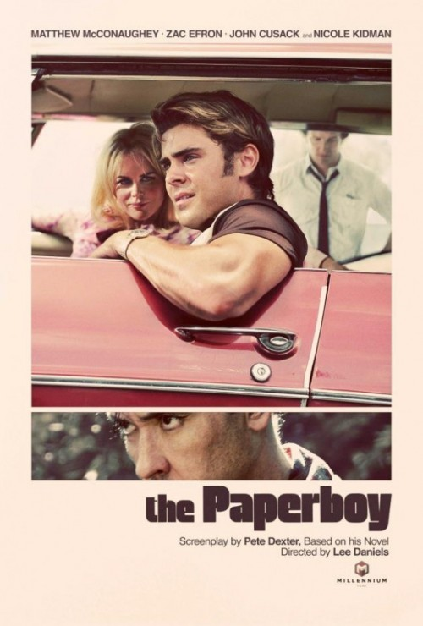
The scene in The Paperboy where Nicole Kidman pees on Zac Efron was nearly left on the cutting room floor. However, Kidman talked the director into keeping it, because the initial three days of filming were basically abstract shots from an oddly-specific fetish movie. Director Lee Daniels gives an interview with GQ that I’ll have to excerpt below because I only have so much skill to soundbite a plot about ‘telepathic sex scenes in prison’ and ‘swimming off hard-ons.’
- On the scene where Nicole Kidman urinates on Zac Efron’s ‘face and bare chest’: ‘Well, I got nervous at the end, after we shot it. So I called Nicole. First of all, it was really hard to shoot. It was the third day. The first scene we shot was the sex scene with John [Cusack and Kidman]. I like to get that right out of the way. The second day was the telepathic sex scene in the prison. And the third day of shooting was the piss scene.’
- On worrying he’d gone too far: ‘Right before I sent it off to Cannes, I called Nicole at three in the morning. I said, ‘Nicole, I can’t do it, I’ve gone too far. I can’t put that scene in the movie.’ She said, ‘Lee, you made me pee on Zac Efron, if you don’t put that in the movie, you’re out of your freakin’ mind. I did it! I did it!’ She said, ‘No way, you’re out of your mind.’ So we put it in. That was the one where I thought, ‘Oh… No…’ When you’re doing the script it makes sense, when you’re shooting it, it makes sense, but then you see the totality and you’re like, ‘Woah. Woah.”
- On the lead up to that scene: ‘Look, the dude [Efron] gets a hard-on because he’s sitting there staring at [Kidman's] ass. But I couldn’t go there because I refused to show the hard-on. I wasn’t going to do that. Then she says, ‘Take that hard-on and go over to those other girls [nearby on the beach].’ In the book, he goes into the water to swim off the hard-on, but I had to reconstruct the scene because it was too much.’
- …so, it’s already toned down: ‘It’s already way down, dude! Way down. And then he goes swimming and he’s attacked by jellyfish. And how you fix it is with urine. And it’s brilliantly written by Pete Dexter.’

